**ACTIVE Spartans Physical Activity Mentor Opportunity** 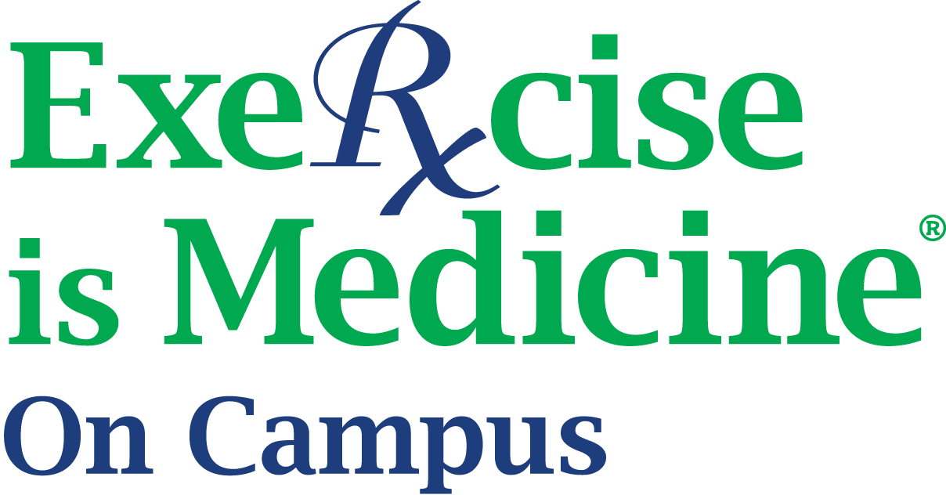

**Applications will be considered on a rolling basis.**

**Send resumes to Angela Maniaci**

[**maniaci8@msu.edu**](mailto:maniaci8@msu.edu)

This program seeks dynamic and innovative undergraduate or graduate students to serve as Physical Activity Mentors (PAMs). Physical Activity Mentors will help fellow students develop, implement, and maintain positive physical activity behaviors.

**Position Requirements:**

* Preferred experience/knowledge in physical activity programming, fitness assessments, and/or behavior change strategies through previous internships, employment, coursework, or volunteer work.
  + Background in Kinesiology, Public Health, Health Communication, or a related field.
* Strong verbal and written communication skills.
* Ability to work both independently and as part of a group, and be reliable, dependable, and professional.
* Become an active member of the [Exercise is Medicine on Campus RSO](https://healthpromotion.msu.edu/fitness/eimoc/index.html) (EIM-OC) for the duration of time as a PAM (there is no fee to join; login to [Involve@State](https://spartanexperiences.msu.edu/rso-s/RSOH/InvolveatState%20Platform.html) for more information)
* Training will be provided and is required for the position.
  + PAMs will receive 5-6 hours of expert training including a mix of virtual and in-person sessions to prepare them for a mentee.

**Primary Learning Outcomes:**

* Develop skills related to supporting and coaching participants on developing, implementing, and maintaining positive physical activity behaviors.
* Gain a deeper understanding of theory and best practices in health promotion and lifestyle behavior development, and health promotion programs and resources.

**Primary Responsibilities:**

* Mentor [ACTIVE Spartans](https://healthpromotion.msu.edu/fitness/activespartans/index.html) participants through the development, implementation, and maintenance of positive physical activity behaviors.
* Provide opportunities and resources for diverse and inclusive physical activity offerings on campus.
* Communicate and collaborate with on-campus partners to support and further the development of positive physical activity behaviors
* Incorporate theory and research on best practices in health promotion and lifestyle behavior development (e.g. Self-Determination Theory, Transtheoretical/Stages of Change Model, Theory of Planned Behavior)
* Time requirements: 30 min - 2 hours/week
  + Pre and post fitness assessment and goal setting, accountability, and/or workouts
  + Weekly tracker, semester post survey, EIM-OC RSO meetings

**Benefits to Mentors:**

* Training and skill development that can be added to your resume and Spartan Experience Record.
* Experience with health promotion and engagement programs in a university setting.
* Networking with university faculty/staff in the field of health promotion and physical activity/exercise.
* Making a difference in the lives of fellow students by promoting positive health behaviors.

**Interested in becoming a mentor? Fill out our** [**ACTIVE Spartans Mentor Application here.**](https://msu.co1.qualtrics.com/jfe/form/SV_bjsoExxLgDEIkCy)